Hatta Camping Spots for Motorhomes (UAE Guide)
Nestled in the rugged Hajar Mountains, Hatta has become one of the UAE’s top outdoor destinations for motorhome and caravan camping. Just 1.5 hours from Dubai, it offers mountain views, cool weather, and dedicated camping areas perfect for RV travelers.

🏕️ 1. Hatta Camping Site (Official Campground)
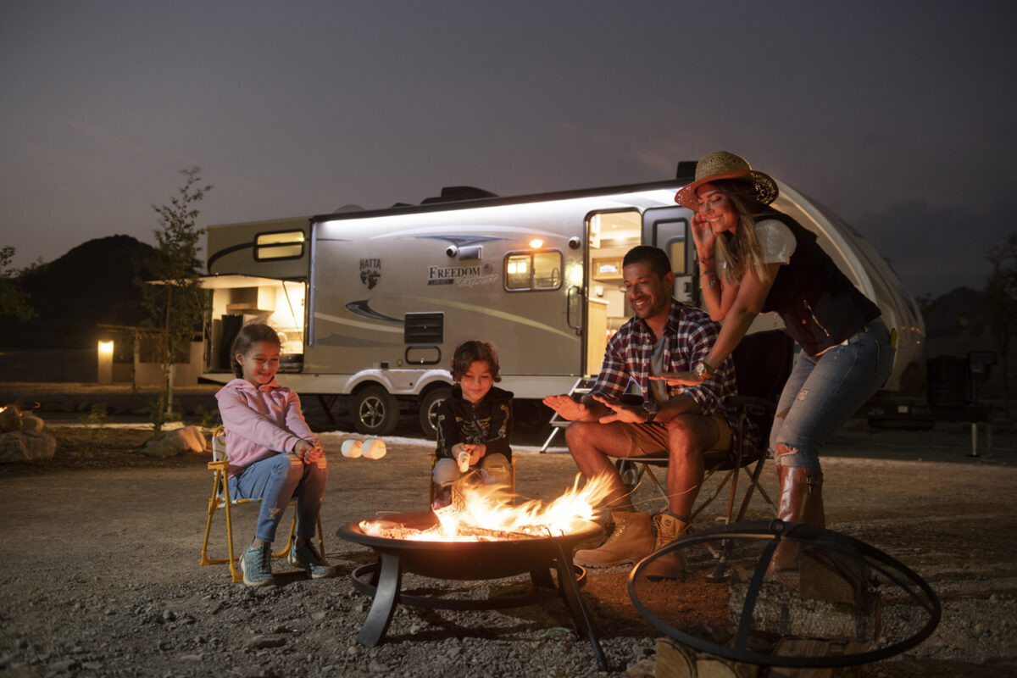
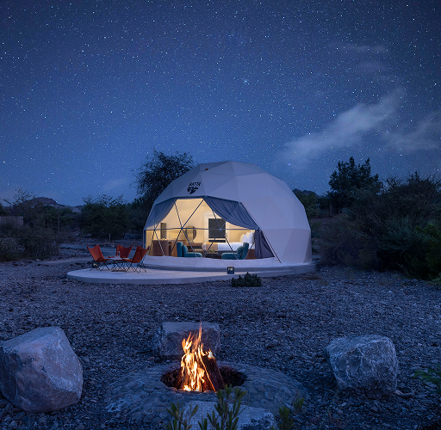
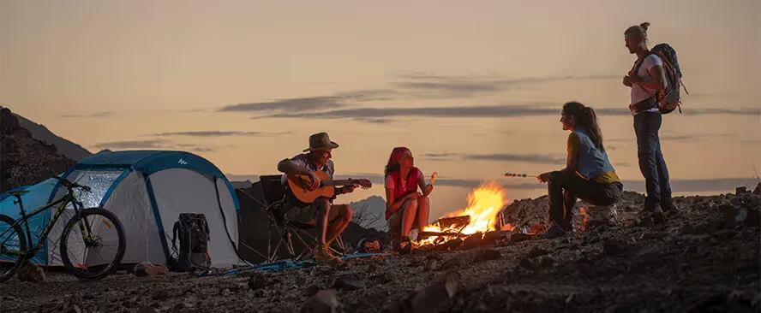
4
The Hatta Camp Site is the main designated area for campers and motorhomes.
Why it’s great for motorhomes:
- Dedicated parking space for cars and small trailers
- BBQ stations, fire pits, and seating included
- 24-hour security and organized camping slots
- Close to Wadi Hub (food trucks, activities)
You can bring your own caravan or trailer and park within marked slots, making it one of the safest and easiest places for first-time motorhome campers.
👉 Best for: Families and beginners with caravans

🚐 2. Hatta Caravan Park (Luxury Static Caravans)

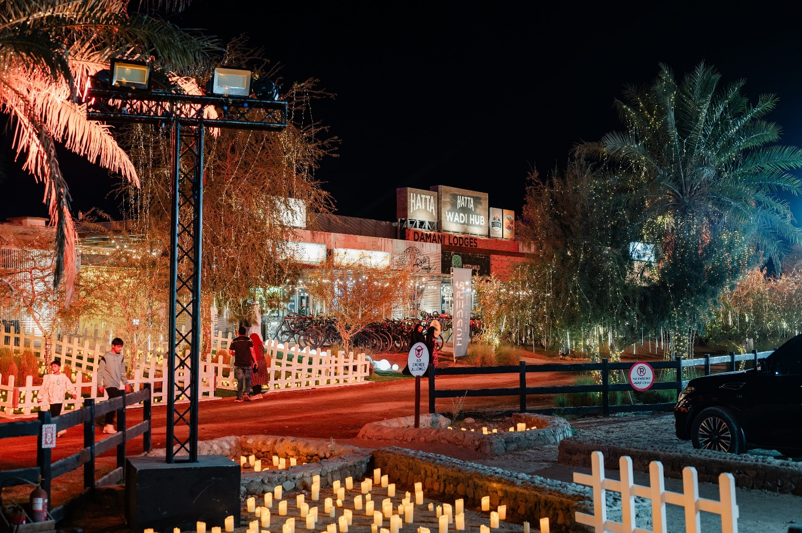
4
If you want a motorhome-style experience without driving one, check out Hatta Caravan Park.
Features:
- Fully equipped caravans (TV, Wi-Fi, kitchenette)
- Stylish interiors with wood and leather finishes
- Park your car next to the unit
- BBQ areas + nearby dining
This is a stationary caravan setup, ideal if you want comfort while still enjoying the outdoor feel.
👉 Best for: Luxury camping (glamping) lovers

🌄 3. Caravan Hatta by Our Habitas
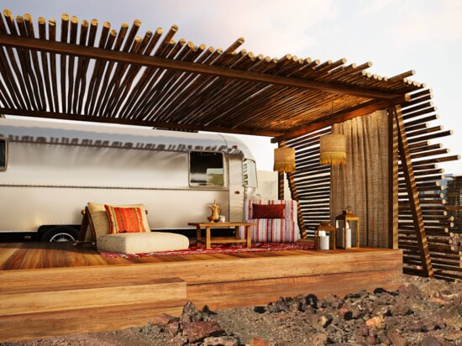
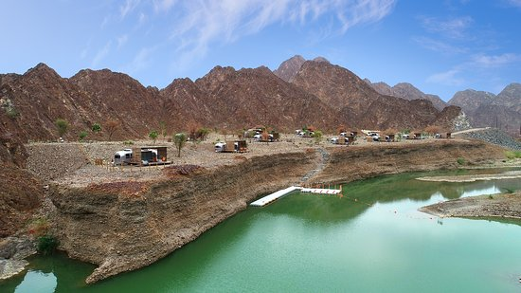
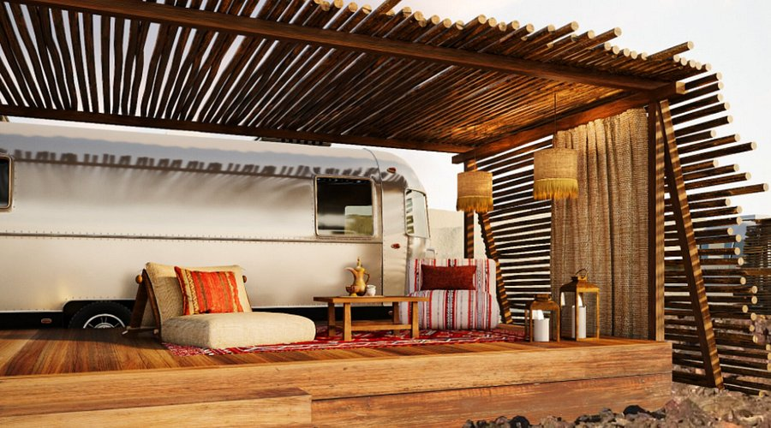
4
The Caravan Hatta by Our Habitas is one of the most scenic caravan-style resorts in the region.
Highlights:
- 50+ designed caravans in a mountain setting
- Community-style outdoor spaces
- Access to hiking, biking, and wellness activities
- Strong “nature + lifestyle” experience
This is more of a premium caravan village, blending motorhome aesthetics with resort comfort.
👉 Best for: Couples, lifestyle travelers, Instagram-worthy stays

🌿 4. Quiet Farm Caravan (Private Motorhome Stay)
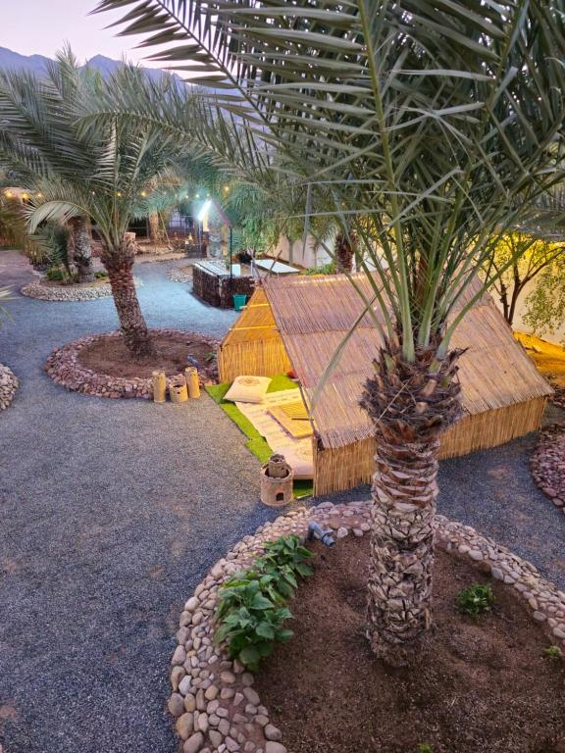
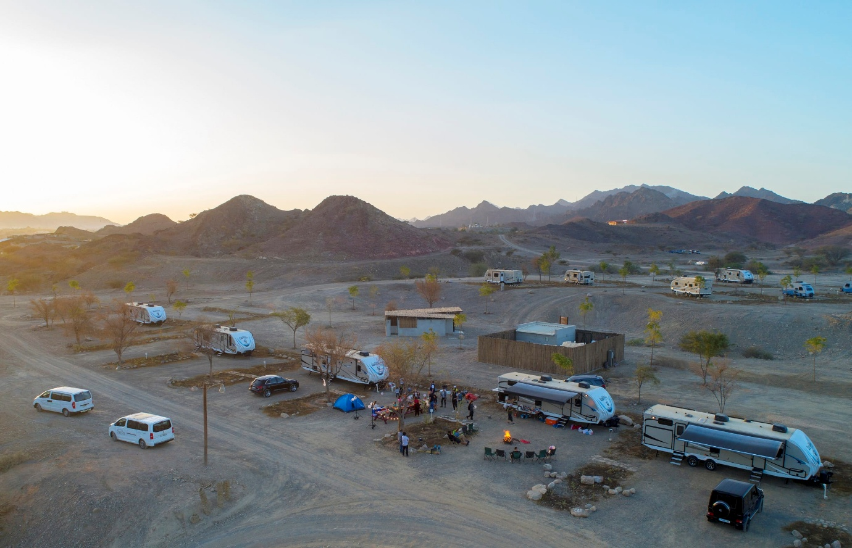
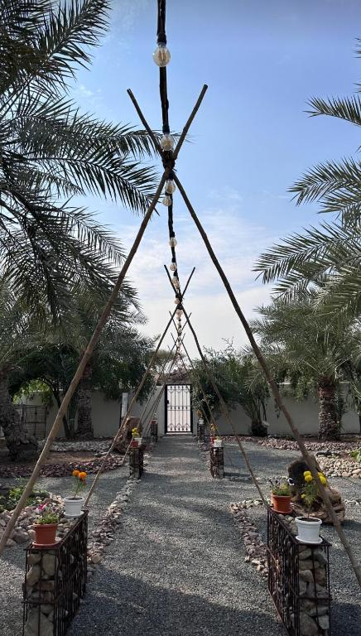
4
For a more peaceful experience, Quiet Farm Caravan offers a quieter, semi-private camping vibe.
What to expect:
- Garden setting with mountain views
- Outdoor seating and BBQ areas
- Pet-friendly environment
- Less crowded than public camps
👉 Best for: Private motorhome-style relaxation

🏜️ 5. Free Camping Areas Around Hatta (Wild Camping)
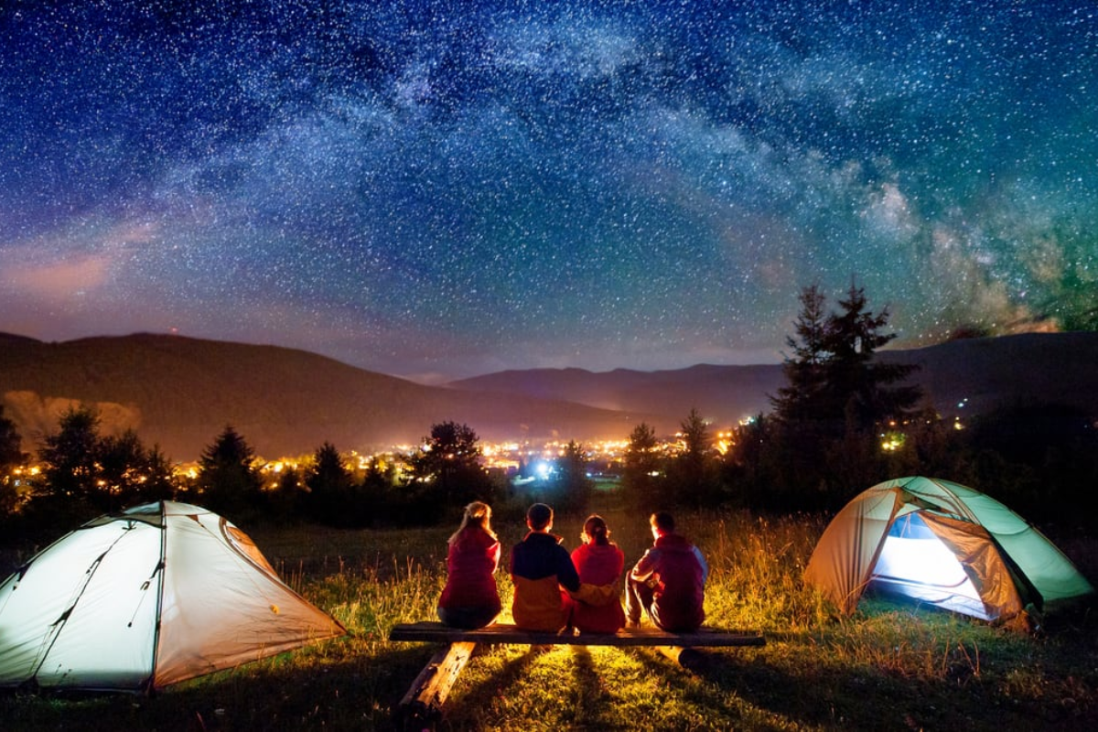
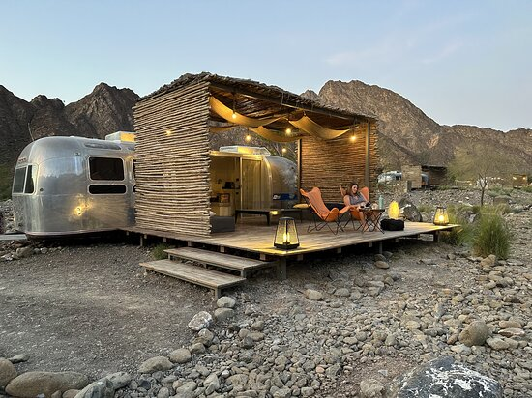
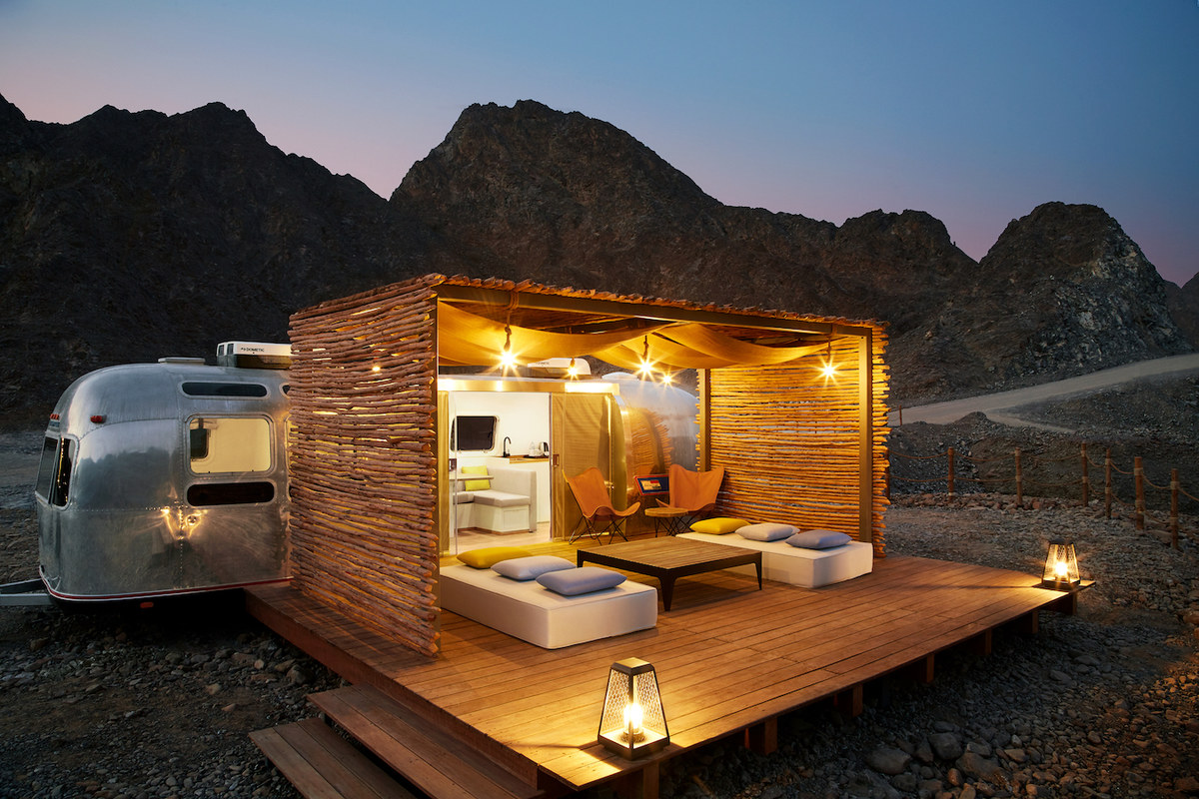
4
Hatta also allows informal camping in open areas (outside restricted zones).
Key points:
- Park your motorhome near mountain tracks or open desert
- No facilities (self-sufficient setup required)
- Incredible views and stargazing
- Choose safe, accessible terrain
Many campers prefer this for a true off-grid motorhome experience.
👉 Best for: Experienced campers with fully equipped RVs

🧭 Tips for Motorhome Camping in Hatta
- Best season: October to April (cool weather)
- Vehicle type: SUVs or well-equipped motorhomes recommended
- Essentials: Water tanks, generator/solar, waste disposal plan
- Rules: Avoid restricted areas and respect nature

⭐ Final Thoughts
Hatta is one of the best motorhome camping destinations in the UAE, offering everything from organized campsites to luxury caravans and wild camping spots. Whether you’re traveling with a fully equipped RV or just exploring caravan-style stays, Hatta delivers a perfect mix of adventure and comfort.

If you want, I can also suggest exact GPS spots for motorhome parking in Hatta or create a weekend itinerary from Dubai with your caravan 🚐

